Megan Baillargeon
Period 2
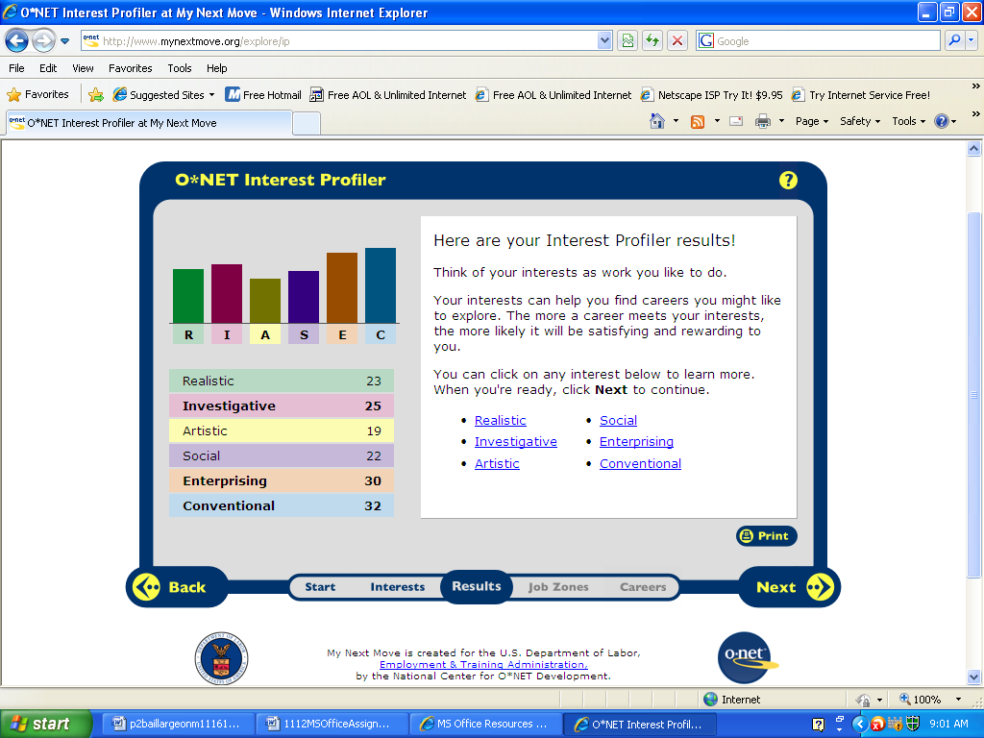
My highest score was Conventional with 32 points. I find my results to be very accurate. Conventional, which was my highest score best fits my style in working. People with conventional interests follow set rules and routines and prefer working with information and paying attention to the little details. I find this style to fit me because I run my life with daily routines. I’d prefer to have information right in front of me rather than having an idea of what’s going on.

Conventional careers
Top 8 Careers:
- Bookkeeper
- Accounting clerk
- Postal service clerk
- Loan interviewer
- Credit analyst
- Occupational health & safety
- Technician
- Court reporter

HR1. What is the definition of each occupation that your group has chosen and the nature of the work?
- Bookkeeper: update and maintain accounting records, including those which calculate expenditures, receipts, accounts payable and receivable, and profit and loss.
- Accounting clerk: They check figures, postings, and documents to ensure that they are mathematically accurate, and properly coded.
- Postal service clerk: sell stamps, money orders, postal stationery, and mailing envelopes and boxes in post offices throughout the country. These workers register, certify, and insure mail, calculate and collect postage, and answer questions about other postal matters.
- Loan interviewer: , interview applicants and others to obtain and verify personal and financial information for the purposes of completing loan applications
- Credit analyst: Analyze current credit data and financial statements of individuals or firms to determine the degree of risk involved in extending credit or lending money
- Occupational health & safety: help prevent harm to workers, property, the environment, and the general public.
- (Pharmacy) Technician: help licensed pharmacists prepare prescription medications, provide customer service, and perform administrative duties within a pharmacy setting.
- Court reporter: create verbatim transcripts of speeches, conversations, legal proceedings, meetings, and other events. Written accounts of spoken words are sometimes necessary for correspondence, records, or legal proof, and court reporters provide those accounts.

HR2. What are some of the related occupational fields?
1. Bookkeeper: Bookkeeping, accounting, and auditing clerks
2. Accounting Clerk: accounts payable clerk or accounts receivable clerk
3. Postal Service Clerk: Counter and rental clerks; Postal Service mail carriers; Postal Service mail sorters, processors, and processing machine operators; Shipping, receiving, and traffic clerks.
4. Loan Interviewer: Loan Processor, Loan Officer, Mortgage Loan Processor, Loan Analyst, Loan Clerk, Underwriter, Loan Closer, Processor, Production Assistant, Closer
5. Credit Analyst:

HR3. Which personality type(s) is best suited to the occupations/jobs you have researched?
1. Bookkeeper: Clerks should also have good communication skills, be detail oriented, and trustworthy.
2. Accounting Clerk: must be careful, orderly, and detail-oriented to avoid making errors and to recognize errors made by others. Should be discreet and trustworthy, have good communication skills, because they increasingly work with customers
3. Postal Service Clerk: you’d have to be trustworthy and honest because you’re handling mail that could have very important information in it and if that information is stolen it could extremely impact someone’s life, depending on what it is.
4. Loan Interviewer: Excellent written and verbal communication skills are essential.
HR4. What kind of education, training and qualifications are required?
- Bookkeeper: a high school degree at a minimum. These workers also should be discreet and trustworthy, because they frequently come in contact with confidential material. They should also have good communication skills, because they increasingly work with customers.
- Accounting Clerk: postsecondary education is increasingly important and an associate degree in business or accounting is required for some positions. Some formal classroom training also may be necessary, such as training in specialized computer software.
- Postal Service Clerk: are required to take an examination. Additionally, they must be at least 18 years of age and a U.S. citizen or have been granted permanent resident-alien status in the United States. Males must have registered with the Selective Service upon reaching age 18. A good command of the English language is also required.
- Loan Interviewer: A high school diploma or equivalent is the minimum needed to get into the occupation. new interviewers receive short-term on-the-job-training to learn about pricing loans and about the rules and regulations regarding the issuing of loans
HR5. What technology skills are needed to be successful in the career/occupational fields you have explored?
- Bookkeeper: must be comfortable using computers to calculate and record data.
- Accounting Clerk: Workers must be able to use computers, and knowledge of specialized bookkeeping or accounting software is especially valuable.
- Postal Service Clerk:
- Loan Interviewer: including good customer service, math, and telephone skills.
RC1. What does each occupation pay, or what are the average earnings nationally and in this area of the country?
1. Bookkeeper: The top 10 percent of bookkeeping, accounting, and auditing clerks earned more than $49,260, and the bottom 10 percent earned less than $20,950.
2. Accounting Clerk: The top 10 percent of bookkeeping, accounting, and auditing clerks earned more than $49,260, and the bottom 10 percent earned less than $20,950.
3. Postal Service Clerk: Median annual wages of postal service clerks were $51,040 in May 2008
4. Loan Interviewer: Median annual wages for loan interviewers and clerks were $32,470 in May 2008.
5. Credit Analyst: Median annual wages $28.29 hourly, $58,850 annual
RC2. What is the projected growth for this career field over the next 10 years? (i.e. will there be more or less jobs like this in the future?)
- Bookkeeper: The large size of this occupation ensures plentiful job openings, including many opportunities for temporary and part-time work.
- Accounting Clerk: The large size of this occu pation ensures plentiful job openings, including many opportunities for temporary and part-time work
- Postal Service Clerk: Employment is projected to decline rapidly. Postal Service clerks will be adversely affected by the decline in first-class mail volume because of the increasing use of electronic mail and automated bill pay.
- Loan Interviewer: is projected to grow slower than the average for all occupations. A growing population will spur demand for home loans and for loan interviewers to verify and process financial data on the application and to assemble documents and prepare them for settlement. the increasing use of online applications will limit demand for loan interviewers.
- Credit Analyst: Faster than average (14% to 19%)
RC3. Please identify local or national organizations that would hire someone in each career field you have explored.
- Bookkeeper:
- Accounting Clerk:
- Postal Service Clerk:
- Loan Interviewer:
ISC1. What are the working conditions or work environment for each job you or your group decided to research (such as work schedule, hours, exempt/salaried or non-exempt/hourly, etc.)?
- Bookkeeper: They may experience eye and muscle strain, backaches, headaches, and repetitive motion injuries from using computers on a daily basis. work regular business hours and a standard 40-hour week.
- Accounting Clerk: They may experience eye and muscle strain, backaches, headaches, and repetitive motion injuries from using computers on a daily basis. may have to sit for extended periods while reviewing detailed data.
- Postal Service Clerk:
- Loan Interviewer:
- Credit Analyst:
ISC2. Are positions in this career field typically part of collective bargaining units (unions)?
- Bookkeeper: State and local government, educational services, healthcare, and the accounting, tax preparation, bookkeeping, and payroll services industries are among the individual industries employing the largest numbers of these clerks.
- Accounting Clerk: ^
- Postal Service Clerk:
- Loan Interviewer:
ISC3. What kind of opportunities for advancement are there for each career? (i.e. Is there a chance to get promoted, etc.?)
- Bookkeeper: usually advance by taking on more duties for higher pay or by transferring to a closely related occupation
- Accounting Clerk: Most companies fill office and administrative support supervisory and managerial positions by promoting individuals from within their organizations, so clerks who acquire additional skills, experience, and training improve their advancement opportunities.
- Postal Service Clerk: The number of applicants usually exceeds the number of job openings because of the occupation's low entry requirements and attractive wages and benefits.
- Loan Interviewer:

